Cairngorms Park For All Fund

Information on Fund, Frequently Asked Questions and example of a completed application form for group / individual

Background and eligibility
The Cairngorms Trust has co-developed with a lived experience panel a fund to encourage members of the Black and Minority Ethnic (BAME) community to be able to access the outdoors in the Cairngorms. To promote connection to nature and community and inspire environmental awareness creating positive change within the Cairngorms National Park.

The fund is for:
- People who live within the Cairngorms National Park to support activity with members of BAME communities that will be delivered within the Cairngorms National Park
- People and organisations that promote inclusive activity with under-represented groups within the Cairngorms National Park
- Activity that works with local providers within the Cairngorms National Park

The fund will support projects or activities that includes some or all the following fund priorities:
- Inclusion and under-represented groups
- Building community, networks and interactions between people
- Sustainability, biodiversity and addressing the climate emergency
- Skills development or courses
- Inter-generational projects
- Art, creativity and culture
- Nature connection
- Fun, health, happiness & well being

Examples of what the fund will support include:
- Money for skills training e.g. Navigation Courses, Winter Skills, Professional outdoor qualifications, Art classes, Wild-life ID, Outdoor First Aid
- Money for equipment and kit, such as outdoor activities (e.g. tents, guidebooks, waterproofs, binoculars etc), creative materials (e.g. art materials and photography equipment etc), gardening and outdoor tools (e.g. moth traps, pond dipping, plants and trees, etc)
- Events and activities that bring people together

Please note, this fund cannot pay for retrospective activities or purchases. All activities and purchases paid for by the fund must take place after the formal offer of grant has been agreed.

Individuals can apply for up to £500. Groups and organisations can apply for a maximum of £1,500.

All projects must be completed by 28th February 2026

Timeline for Fund:
Opens for applications: 6th January 2025
Closes for applications: midnight Sunday 2nd February
Questions and assistance with applications: 7th January to 30th January 2025 all questions to communitygrants@cairngorms.co.uk
Decision meeting: takes place in February 2025
Projects run: 1st March 2025 to 28th Feb 2026.

See FAQs below for additional information.

Frequently asked questions

Who has designed this fund?
The Cairngorms Trust has co-designed this fund with a lived experience panel and facilitator. Our lived experience panel consists of members from BAME communities in and around the Cairngorms National Park. If you would like to join this panel, please contact cairngormstrust@cairngorms.co.uk

Who can apply for this fund?
This fund is aimed at members of BAME communities, both individuals and groups. The fund may also be applied to on behalf of such groups or individuals

What I am looking to do doesn’t quite fit with your criteria, can I still apply?
Please get in touch! The fund is flexible, and we are looking to support as much quality activity as possible.

Can an application be made on behalf of a group?
Yes we will accept applications on behalf of a group.

I don’t live within the Cairngorms National Park but would like to visit and do some activity there, can we apply?
Priorities are given to those who live in the Cairngorms, then those who have connections with the Cairngorms. For example - your immediate family live in the Cairngorms; you work within the Cairngorms but live in another area; you went to school in the Cairngorms or are planning to move back soon to the Cairngorms. This is not an exhaustive list, so please do contact us if you have questions. If you do not fall into either of these two categories but are keen to visit the Cairngorms you are welcome to submit an application, and it will be looked at as part of the process.
Please note if it is travel to the Cairngorms you are wanting to gain funding for, you might be able to apply to the Cairngorms National Park Authority Travel Grant for financial support to travel to the Park. Travel Grant Scheme - Cairngorms National Park Authority

Is there anything the money can’t be used for?
All funds need to be used as described in application form.
The fund can’t be spent on alcohol, anything you do must be legal. If you are running an event or constructing something you must get landowner or other appropriate permissions.

What if my project will not be finished by 28th February 2026?
Unfortunately, we can only fund activity that will be completed before the date above.

I’d like to use this fund but am not quite clear on my ideas yet, what should I do?
Have a read through the examples, have a think and get in touch! We can talk through your ideas and help you out. We have time built into this fund to assist you with your application form.

What evidence will I need to submit with the application?
If applying for capital items (i.e., kit and equipment) or courses, please provide a quote or link to demonstrate the price of the item. Afterwards you will need to provide proof of payment, which can be a receipt showing payment or an invoice and bank statement showing payment of invoice. So please keep your receipts, we cannot pay out a claim without them.

I have been offered funding – what will I receive and when?
We will give you 50% of the money up front and the other 50% when you have completed the activity/bought the item and submitted proof of payment (see above paragraph), completed an evaluation form and submitted photos. If this will be a problem, please speak to us and your host organisation and we can try to solve this challenge.

I have received my grant offer letter and I would like to change what it is spent on.
This is not ideal as your application was assessed on the original project. However, we are aware that prices change, or dates alter and will hopefully be able to accommodate minor changes like that. Please contact us as soon as possible to chat through the changes and we will work out whether they can continue to be funded. Please do not go ahead with the changes without speaking to us as we may not be able to pay out the grant.

I have successfully received funding – what will I need to do after I have finished the project?
We will send you a link to an evaluation form to complete. You will need to provide the invoices / bank statements / receipts. We will also want some creative documentation of your project. This might be photos, videos, blog posts or artwork, it’s up to you! We regularly share these on the Cairngorms Trust social media, website and other outlets.

Please note our terms and conditions on submission and subsequent of photographs and artwork etc. These are detailed under section 7, specifically 7.5 and 7.6 on our use of your photographs and also within your Offer of Grant letter. This is specifically to do with publishing photographs, if there are any challenges with this please contact us directly and we can ensure there is the option to opt out of any publicity associated with your grant.

This fund is a new fund for us, but to see some examples of projects that we have supported through our other funds please follow this link to our case studies section of our website. Projects | Cairngorms Trust

Example Application form for both Groups and Individual applicants

Name | I Shahnaz
Email | ishanhnaz@example.com
Phone number | 0700 000000
Address | 1 Somewhere Road, Highlands

Project Name | Equipment for Nature Group Equipment for Nature Walks
Group Name  (if applicable) | Example Nature Group
Group Type (charity, CIC, constituted, non constituted etc) A group is 3 or more people. | Led by Aberdeen Asylum and Refugee Care
What is your role in the group | Organiser

How many people will directly benefit from the project?
Group – 12 in total

Individual - 1

Please tell us about your group (who is the group aimed at, what do you do, etc) 250 words max.
We are a group of refugees who love nature and are keen to be able to connect with nature in the Cairngorms.

I have recently arrived in the UK and was a keen hillwalker in xxxx. I would like to be able to connect with nature in the cairngorms.

What is the money for? £500 max for individuals, £1,500 max for groups. 500 words max

Group response - The funds will be used to purchase optical equipment and camera traps to allow the group to see a wide range of birds and mammals regularly at sessions.

Having their own suite of binoculars and telescopes would allow us to provide the group members with binoculars during their sessions in the outdoors with the activity providers, allowing them to see for themselves wildlife that is less visible with the naked eye.

The staff delivering the programme are trained in the use of optics and would be able provide instruction to the group members for each session. The partner organisations involved in the delivery are based in nature rich land holdings and are proficient at showing this to a wide audience.

Discovering, observing and understanding wildlife is often one of the first steps taken in the journey to caring for the natural environment

Individual response - The money will be used to buy optics and camera trapping equipment for myself.

As an individual living in the national park, personal use of optics/expensive cameras is restricted to those who have access already or those who come from a higher income household.

Having my own suite of binoculars and telescopes would allow me to see for myself wildlife that is less visible with the naked eye.

Having a pair of binoculars myself allows for a more personal connection with nature, and will give me the chance to self-discover and spot wildlife on outings.

Where in the Cairngorms National Park will your activity take place?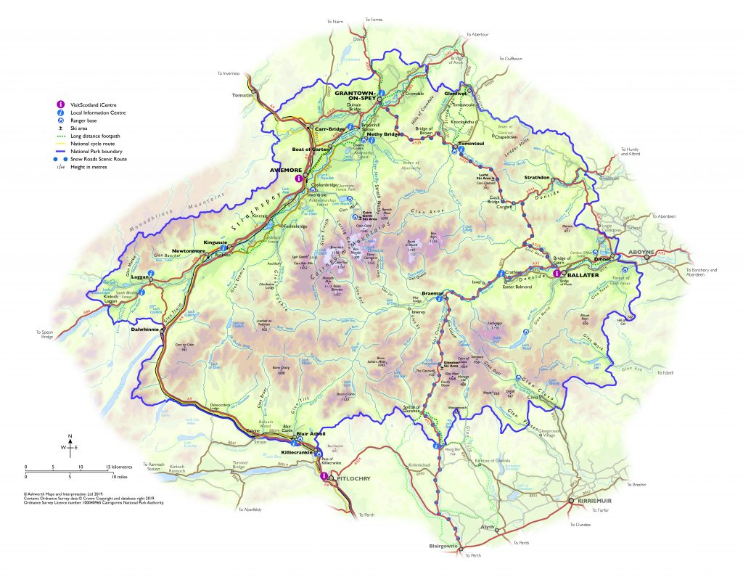
Group - The project is based in Speyside, making use of outdoor spaces in the national park. The programme is delivered by experienced leaders working with local organisations and the ranger services and other conservation organisations in the national park.

Individual – As I live in Glenmore, I have access directly outside my front door to the outdoors and the majority of my activity will take place on Cairngorm Mountain.

This fund is primarily aimed at those who live in the Cairngorms, but we will also accept applications from those who live in the surrounding areas. If you live out with the Cairngorms you can apply to the CNPA travel grant Travel Grant Scheme - Cairngorms National Park Authority

Do you live permanently in the Cairngorms National Park? Yes / No
Group – No we are based in Pitlochry but 5 out of the 8 people we work with live within the Cairngorms National Park and the other members have good connections and regularly visit the Cairngorms.

Individual – Yes I live in Kingussie.

If you don’t live in the Cairngorms,
Where do you live? Group – We are based in Aberdeen Individual – I live in Perth
How often do you visit the Cairngorms? Group – At least once a month Individual – Every week
What do you do when you are here? Group – Walking and bird watching Individual – Cycling and exploring nature

If you have not visited the Cairngorms before,
Where do you live? Group – Dundee Individual - Inverness
What are your connections to the Cairngorms? Group – None at the moment,
Individual – None at the moment.
Why would you like to visit? Group - we have watched documentaries about the Cairngorms and would like to visit soon

Individual - My friend visited Ballater last year and recommended I visit

Tell us how your project fits with our fund priorities below. Please write a few sentences for each priority that is relevant to your project. Your project does not need to link to each category.

(You can answer this question through images or video if you prefer. Please attach to your email or put a link in this box).

Inclusion and under-represented groups
There are no prerequisites to participate in the youth project, other than being 11-18 – it does not matter if someone is in school or not for the monthly programme. We understand that there are geographic barriers to participation by sessions being mainly based in the national park, but we will offer opportunities in different locations around the national park to address this. Beyond the Cairngorms, the youth group will look to create a series of online content aimed to inspire others to get outside and care for their own wild spaces.

Building community. Networks and interactions between people
This programme has been warmly welcomed as a great & worthwhile project to be involved with across a variety of partnership organisations in the national park. There is much agreement across communities and organisations that young people will be the future stewards of the land and climate & therefore well worth contributing ideas and time to a project such as this. We aim to have a wider reach across the national park and beyond, including as many different partner ranger services in the delivery of the programme as possible. The participants will have the opportunity to meet a wide range of people across the national park and also be able to elect to attend meaningful trips which join with other similar programmes around the UK and beyond, extending their network and building confidence/self-esteem by meeting new people. Many of the members are from rural backgrounds, where isolation is more common – making the community aspect of the programme even more important.

Sustainability, biodiversity and addressing the climate emergency
Many of the people in the programme are extremely switched on to bigger picture of the climate emergency. We hope to provide a platform for the people in the programme to share their environmental messages with the wider population, via social media, videos, campaigns and activities. This would range from local efforts such as litter picks, to larger online campaigns in line with bigger environmental events (e.g COP).

Skills development or courses
The programme aims to teach many of the vocational skills needed for a career in conservation. More than this – by mixing with like-minded people from a mixture of ages in a safe & non-judgemental outdoor environment, their confidence and interpersonal skills will grow too. All participants will be offered the opportunity to earn varying levels of the John Muir Award that correlate to the amount of time spent with the programme.

Intergenerational Projects
Going forward, we aim to allow the older members develop leadership roles to help plan their own events and internally. We intend for the programme to take an active role in helping out local communities, giving the group members a chance to mix with local people of all ages.

Art, creativity and culture
We have a popular focus in sessions on natural art, enjoyed by all of the group members, using materials from around the surroundings. Feedback from our initial sessions was that natural art was both enjoyed and beneficial as a reflective exercise and we will continue this in the future.
Nature Connection
Every session will help establish group members’ connection with nature. There will be a huge variety of nature-based activities to appeal to a wide variety of participant personalities and backgrounds.

Fun, health, happiness and well being
A core value in the programme is that sessions are fun and enjoyable, and almost always taking part in outdoor spaces. While the participants will learn a huge amount from their time with us, it will be via a non-academic, holistic approach to outdoor learning. Most of the sessions will have practical conservation elements and will always have dynamic and engaging staff members involved in each activity.

What benefits will the project have beyond the funding period?

Group – The binoculars will be part of the group going forward and will be used by future members of the project. More established and knowledgeable members of the group will be able to share information as part of the sessions.
Individual – The binoculars will allow me to gain more confidence and volunteer for the rangers service in the following years.

How much money are you applying for? Individuals (up to £500) or Groups (up to £1,500):

Please use the table below to give us an itemised description of what you will spend the money on. Do not buy anything until you have received the offer of grant. If you are looking at capital items for your project then please look to kit libraries such as Àban Outdoors in Inverness Outdoor Gear Hub - Àban. Your local authority may also have access to hire kit which might free up budget for activities within the project.

If applying for capital items (i.e. you are buying equipment) you should provide a quote, screenshot or link to demonstrate the price of the item. The amount you’re applying for can include postage (you don’t have to evidence the postage cost here).

1 day navigation course with Cairngorm Adventure Guides Navigation | Hill Walking | Summer Courses | Cairngorm Adventure Guides

Mens Millbeck Waterproof Walking Boots Peter Storm Men’s Millbeck Waterproof Walking Boots | GO Outdoors

Item/activity Description | Cost(£)
Example: 1 day navigation course (delete) | £75
Example: Walking boots (delete) | £55
Total Cost of Project

Not all applicants will have a suitable bank account to hold funds if successful. Are you in contact with a registered charitable organisation that would host your funds (for example Aberdeen Asylum and Refugee Care, Scottish Highlands & Islands and Moray Chinese Association) Please speak to them if this is applicable. What is the name of the organisation.

Who is the contact person that we can speak to in the organisation?

Phone number.

Email address.

Commitment
I confirm that the information on this form is correct. If I am given a grant, I will spend the money as described above. I will submit receipts, photos and a final report to Cairngorms Trust by 28th February 2026.

Signed (type name if submitting by email):

Tick box if you would like to hear about future funding opportunities and news from Cairngorms Trust.

Thank you!

Please send completed applications to communitygrants@cairngorms.co.uk or via post: Cairngorms Trust, 14 The Square, Grantown-on-Spey, PH26 3HG by no later than Midnight Sunday 2nd February 2025.

