Cairngorms Park For All Application form 2025

Video applications will be accepted, please answer all questions in the same order.

Background and eligibility
The Cairngorms Trust has co-developed with a lived experience panel a fund to encourage members of the Black, Asian & Minority Ethnic (BAME) community to be able to access the outdoors in the Cairngorms, to promote connection to nature and community and inspire environmental awareness creating positive change within the Cairngorms National Park.

The fund is for:
- People who live within the Cairngorms National Park to support activity with members of BAME communities that will be delivered within the Cairngorms National Park
- People and organisations that promote inclusive activity with underrepresented groups
- Activity that works with local providers within the Cairngorms National Park

Please also see our FAQs for more detail.

Name
Email
Phone number
Address

Project Name
Group Name
(if applicable)
Group Type (charity, CIC, constituted, non-constituted etc) A group is 3 or more people.
What is your role in the group?

How many people will directly benefit from the project?
Please tell us about your group (who is the group aimed at, what do you do, etc) 250 words max:

What is the money for? £500 max for individuals, £1,500 max for groups. 500 words max:

Where in the Cairngorms National Park will your activity take place?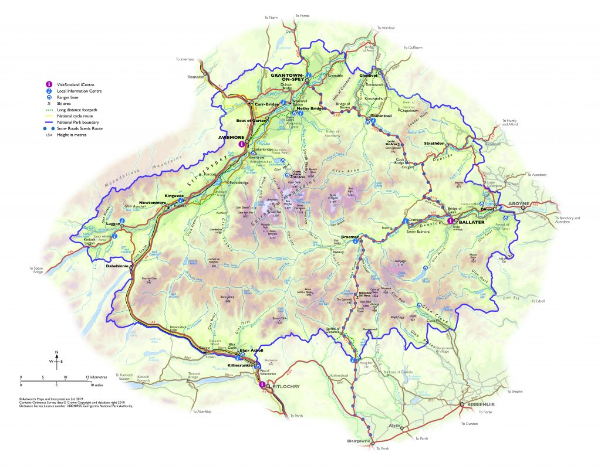

This fund is primarily aimed at those who live in the Cairngorms, but we will also accept applications from those who live in the surrounding areas. If you live out with the Cairngorms there are travel grants that you can apply to through the CNPA which may help you get here Travel Grant Scheme - Cairngorms National Park Authority

Do you live permanently in the Cairngorms National Park? Yes / No

If you don’t live in the Cairngorms -
Where do you live?
How often do you come to visit?
What do you do when you are here?

If you have not visited the Cairngorms before,
Where do you live?
What are your connections to the Cairngorms?
Why would you like to visit?

Tell us how your project fits with our fund priorities below. Please write a few sentences for each priority that is relevant to your project. Your project does not need to link to each category.

(You can answer this question through images or video if you prefer. Please attach to your email or put a link in this box).

Inclusion and under-represented groups

Building community. Networks and interactions between people

Sustainability, biodiversity and addressing the climate emergency

Skills development or courses

Intergenerational Projects

Art, creativity and culture

Nature Connection

Fun, health, happiness and well being

What benefits will the project have beyond the funding period?

How much money are you applying for? Individuals (up to £500) or Groups (up to £1,500):

Please use the table below to give us an itemised description of what you will spend the money on. Do not buy anything until you have received the offer of grant. If you are looking at capital items for your project, then please look to kit libraries such as Àban Outdoors in Inverness Outdoor Gear Hub - Àban. Your local authority may also have access to hire kit which might free up budget for activities within the project.

If applying for capital items (i.e. you are buying equipment) you should provide a quote, screenshot or link to demonstrate the price of the item. The amount you’re applying for can include postage (you don’t have to evidence the postage cost here).

Item/activity Description | Cost(£)
Example: 1 day navigation course (delete) | £75
Example: Walking boots (delete) | £55
Total Cost of Project

Not all applicants will have a suitable bank account to hold funds if successful. Are you in contact with a registered charitable organisation that would host your funds (for example Aberdeen Asylum and Refugee Care, Scottish Highlands & Islands and Moray Chinese Association) Please speak to them if this is applicable. What is the name of the organisation.?

Who is the contact person that we can speak to in the organisation?

Name:

Phone number:

Email address:

Commitment
I confirm that the information on this form is correct. If I am given a grant, I will spend the money as described above. I will submit receipts, photos and a final report to Cairngorms Trust by 28th February 2026.

Signed (type name if submitting by email):

Tick box if you would like to hear about future funding opportunities and news from Cairngorms Trust.

Thank you!

Please send completed applications to communitygrants@cairngorms.co.uk or via post: Cairngorms Trust, 14 The Square, Grantown-on-Spey, PH26 3HG by no later than Midnight Sunday 2nd February 2025.

